**FUNDAMENTALS OF REINFORCEMENT LEARNING**

**Nguyễn Hoàng Việt – QE170216**

**AI17C**

**REL301m**

1. **Certificate**

Link: <https://coursera.org/share/cac46a48c77d447db587290d8c963b88>

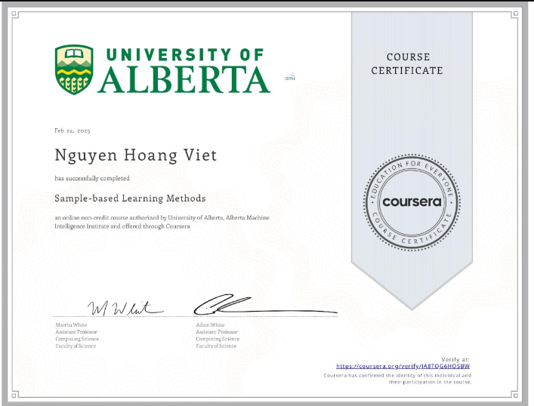

1. **Assignment**

* **Blackjack**: [link github](https://github.com/nguyen-hoang-viet/reinforcement-learning-course/blob/main/assignment/course%202/Blackjack.ipynb)
* **Policy Evaluation with Temporal Difference Learning:** [link github](https://github.com/nguyen-hoang-viet/reinforcement-learning-course/blob/main/assignment/course%202/Policy_Evaluation_with_Temporal_Difference_Learning.ipynb)
* **Q-Learning and Expected SARSA:** [link github](https://github.com/nguyen-hoang-viet/reinforcement-learning-course/blob/main/assignment/course%202/Q-Learning_and_Expected_SARSA.ipynb)
* **Dyna-Q and Dyna-Q+:** [link github](https://github.com/nguyen-hoang-viet/reinforcement-learning-course/blob/main/assignment/course%202/Dyna-Q_and_Dyna-Q%2B.ipynb)

1. **Quiz**

* Graded Quiz

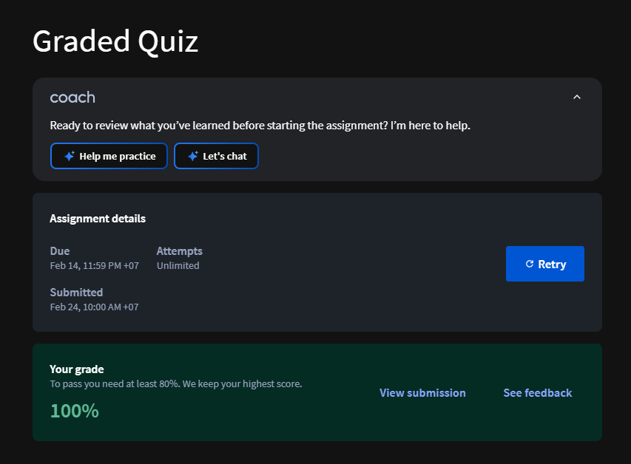

* Practice Quiz

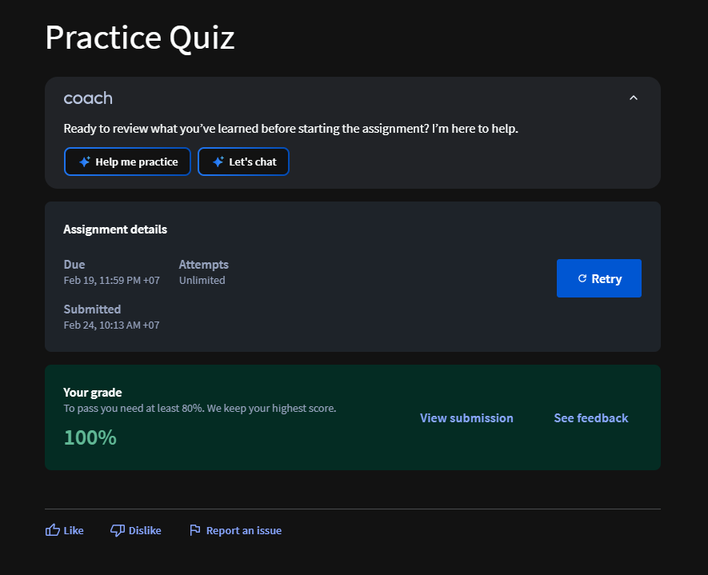

* Practice Quiz

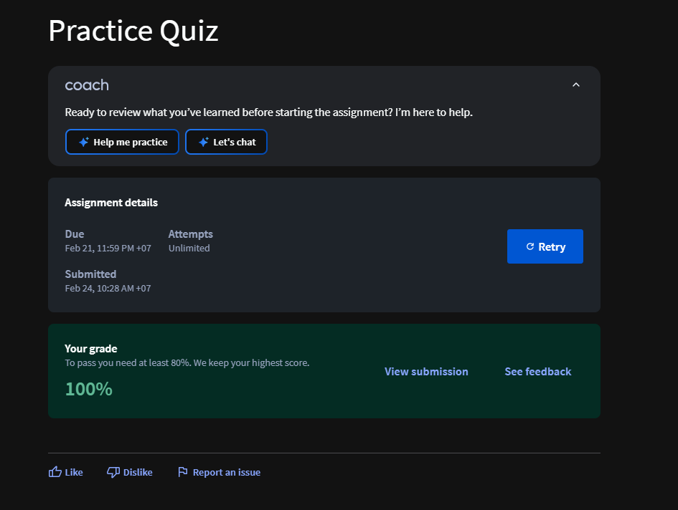

* Practice Assignment

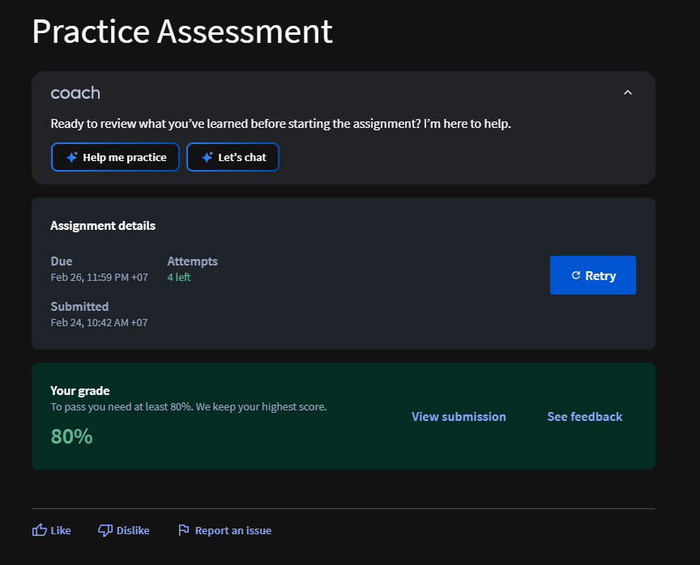

* Total

